Indoor Air Monitoring Protocol

Introduction

Secondhand smoke (SHS) contains at least 250 chemicals that are known to be toxic or carcinogenic, and is itself a known human carcinogen, responsible for an estimated 3,000 lung cancer deaths annually in never smokers in the U.S. as well as over 35,000 deaths annually from coronary heart disease in never smokers and respiratory infections, asthma, Sudden Infant Death Syndrome, and other illnesses in children. Although population-based data show declining SHS exposure in the U.S. overall, SHS exposure remains a major public health concern that is entirely preventable,. Because policies requiring smoke-free environments are the most effective method for reducing SHS exposure in public places, Healthy People 2010 Objective 27-13 encourages all states and the District of Columbia to establish laws on smoke-free indoor air that prohibit smoking or limit it to separately ventilated areas in public places and worksites. Currently, 9 states (California, Delaware, New York, Connecticut, Maine, Massachusetts, Rhode Island, Montana and Vermont), which represent approximately 24% of the U.S. population, have comprehensive clean indoor air regulations in force that cover virtually all indoor worksites including bars and restaurants. In addition, voters in Washington State just approved a ballot initiative making Washington the 10th comprehensive smoke-free state. The Washington State law goes into effect in December 2005. This document will describe a protocol for assessing indoor air quality and the presence of SHS in hospitality venues.

Objectives:

- Assess indoor air quality and provide evidence in support of smoke-free air ordinances in localities that allow smoking indoors
- Evaluate the effectiveness of smoke-free air ordinances after implementation

Methods

Venue selection
The ideal way to select venues would be to randomly sample from the population of venues in question. However, this presents several problems. It may be difficult and time consuming to compile a complete list of the venues in the population to be sampled. Random sampling will result in a list of venues over a wide geographic area, which may be more representative, but may be too difficult to sample from a logistics perspective. In addition, since the number of venues sampled will be small (6-10) relative to the total number of venues (hundreds or thousands) it is unlikely that this random sample will be representative of the entire population of venues in question anyway.
Instead of a random sample, a purposeful convenience sample of venues is used. A minimum of 6 venues should be selected, as at least six venues can be easily sampled in one evening. Venues should be selected to provide a range of venue characteristics such as: type of venue (i.e. bar, restaurant, restaurant with bar etc…), size of venue, and location. Venues should be selected from at least two different geographic areas. Venues can be selected from popular entertainment districts to provide data that is meaningful to a large number of people.

Equipment overview

- Real-time aerosol monitor to measure respirable suspended particulates (RSPs)
- Ultrasonic ruler to determine room volumes
- PC computer running Microsoft Windows with a USB and serial port
- (OPTIONAL) Indoor air quality monitor to measure temperature, humidity, carbon monoxide, and carbon dioxide

A TSI SidePak AM510 Personal Aerosol Monitor (TSI, Inc., St. Paul, MN, www.tsi.com) is used to sample and record the levels of RSP in the air. The SidePak uses a built-in sampling pump to draw air through the device where the particulate matter in the air scatters the light from a laser. Based on the amount of light scattered the device displays the real-time concentration of particles in milligrams per cubic meter. The device weighs slightly over one pound and measures 5.1 in. x 3.7 in. x 2.8 in. The aerosol monitor is fitted with a 2.5 μm impactor in order to measure the concentration of particulate matter with a mass median aerodynamic diameter less than 2.5 μm, or PM_{2.5}. Particles of this size are referred to as “fine particles” and are released in large quantities from burning cigarettes. Fine particles are easily inhaled deep into the lungs and are associated with adverse health effects. The impactor is designed to remove half of the particles at 2.5 μm and larger particles with increasing efficiency. The SidePak continuously measures the particle concentration and is set to record into memory the average level every one minute. The recorded measurements can later be downloaded to a PC for analysis.

The Zircon DM S40 Sonic Measure (Zircon Corporation, Campbell, CA) is an ultrasonic ruler used to measure the volume of each of the venues. By aiming the device at a 90 degree angle to a wall and pushing the button it provides an accurate measure of the distance from the back of the device to the wall in question. This can be used to quickly and easily measure the dimensions of a room (length, width and height), which can be used to calculate the room’s volume. This device is accurate up to 40 feet. While any ultrasonic measuring device can be used in substitute of this model, the DM S40 is one of the smallest, simplest and most discrete ones available. Most models now have a measurement range up to 50 feet. Some models provide a useful laser sight to show you exactly what the device is aimed at but it is not recommended to use the laser feature in order to remain discrete. These devices are commonly sold in hardware stores or can be found online.

A PC computer running Windows 98 or later is necessary to download and analyze the data from the two air monitoring devices. The computer must have an available USB port to communicate with the TSI SidePak and an available serial port to communicate with the TSI Q-TRAK. The computer must also have the data analysis software TRAKPRO version 3.4 or later installed. This software comes bundled with the air monitoring instruments or is available free from TSI (http://www.tsi.com/iaq/downloads/trakpro_download.shtml).

(OPTIONAL) A TSI Q-TRAK Plus Indoor Air Quality Monitor (TSI, Inc., St. Paul, MN, www.tsi.com) is used to sample and record 4 characteristics: temperature, humidity, carbon monoxide and carbon dioxide. Carbon monoxide is a toxic gas emitted from burning tobacco products. Temperature, humidity, and carbon dioxide are general indoor air quality measurements. The carbon dioxide measurements can be used, along with the average number of people and room volume, to estimate the ventilation rate within the venue. The temperature and humidity measurements are also useful in determining when venues are entered and exited. The Q-TRAK operates in a similar fashion as the SidePak aerosol monitor. The Q-TRAK continuously measures the 4 parameters and is set to record the average level of each one into memory every one minute. Again, the data can be downloaded later to a PC for analysis. This indoor air quality monitor is not essential to conduct these types of studies but does provide additional information that may useful depending on your exact study objectives.

Observational data

- average number of people in venue
- average number of burning cigarettes
- other observations: presence of signage, ashtray, etc.

Observational data will also be collected on each venue during air monitoring. First, upon entry, the total number of people in the venue will be counted. This count will be repeated every 15 minutes until the venue is exited. Since a minimum of 30 minutes is spent in each venue there will be at least 3 observations of the number of people in the venue. These observations will be averaged to determine the average number people in the venue during air monitoring.

Next, the number of burning cigarettes should be counted upon entry and again every 15 minutes until exit. As with the number of people, there will be at least 3 observations and these will be average to yield the average number of burning cigarettes in the venue during air monitoring. Please note: this is a count of the number of burning cigarettes and not the number of smokers in the venue. For example, if someone has a pack of cigarettes in front of them but is not actively smoking they don’t get counted. The point is to count the actual number of cigarettes burning at each 15-minute time point.

Lastly, other observational data may be gathered as the investigators see fit. For example, the presence and number of signs indicating where smoking is or is not allowed, the presence of ashtrays, and the presence of visible air filtration devices may all be useful observations. This data may help determine if establishments are operating in accordance with local indoor smoking regulations and will help describe the establishment.

Equipment preparation and operation

TSI SidePak AM510 Personal Aerosol Monitor

There are 3 important steps that the user must perform to prepare the SidePak for operation:

- The batteries must be charged
- The impactor must be cleaned and greased
- The monitor must be zero calibrated

The SidePak is equipped with an internal rechargeable battery pack that can easily provide 10 or more hours of continuous monitoring on a single charge. The SidePak also has a convenient power management feature where the unit conveniently displays the approximate number of minutes the monitor can continue to operate. The impactor is a device attached to the inlet of the SidePak that determines the cut-off size of particles entering the monitor. The SidePak will be fitted with a 2.5 μm impactor that requires cleaning and greasing prior to each use. Finally, prior to each use, the SidePak should be zero calibrated with the included HEPA filter. These 3 preparation steps are detailed in the “Air Monitoring Field Protocol”.

In addition to these 3 steps it is important that the sampling pump in the SidePak is operating at a flow rate of 1.7 liters/minute to ensure the impactor operates properly. Researchers at Roswell Park Cancer Institute will do this step and the user should not have to change the flow rate.

(OPTIONAL) TSI Q-TRAK Plus Indoor Air Quality Monitor

The user should check the batteries on the Q-TRAK prior to each use. The device uses 4 AA batteries and when the unit is on the screen indicates the approximate amount of battery life left. The battery indicator is crude and in order to ensure that data is not lost during a long monitoring session it is recommended that the batteries be replaced when the indicator shows one-half charge or less. It is also recommended that an extra set of 4 AA batteries be carried during all air monitoring excursions.

The CO and CO₂ sensors should also be calibrated monthly. The researchers at Roswell Park Cancer Institute will perform this calibration and the user should not have to perform this step.

Venue monitoring protocol
The specific procedure for air monitoring within venues will depend on the study design and goals of the investigators. The SidePak and Q-TRAK should be placed in a convenient shoulder bag, computer case, or backpack. One end of a length of TygonTM tubing is attached to the inlet of the SidePak and the other end should protrude outside the bag to collect the air to be sampled. The probe from the Q-TRAK should be situated so there is sufficient airflow around the probe. A general protocol to monitor the indoor air quality in a hospitality venue would include:

- record time of entry into venue
- a minimum of 30 minutes should be spent in the venue
- the monitoring bag should be located in a central area
- the bag can be located in a single location or circulated throughout the venue
- the bag can be carried or placed on a table or bar but not on the floor to avoid damage to the devices and to monitor air within people’s normal breathing zone
- observational data should be collected according to protocol; i.e. upon entry, every 15 minutes, and at exit
- record time of exit from venue
- spend at least 5 minutes outside before entering the next venue

It is recommended that the air monitoring be done discretely so as not to disturb the occupants’ normal behavior. It is also recommended that investigators patronize the venues and buy food and/or drinks.

After Monitoring
After air monitoring it is recommended that the SidePak and the Q-TRAK be immediately connected to a PC and the data for that day should be downloaded. This allows the user to check that the data was recorded properly and provides a backup copy of the data in case the data on the device is lost. Refer to the “Air Monitoring Field Protocol” for details on connecting the devices to a PC and downloading the data.

Observational data should also be entered into a spreadsheet program so it can be analyzed later.

Data processing should be done under the supervision of researchers at Roswell Park Cancer Institute. Data processing can include: applying the proper calibration factor to the particulate matter data, determining the average levels of measured parameters such as respirable suspended particulates (PM_{2.5}) and carbon monoxide in each venue, calculating the estimated ventilation rate in each venue, and creating real-time plots of the measured parameters.

The last step is to generate a report with the results of the air monitoring. This can be in the form of a short press release, a full report with extensive text and graphics or a Powerpoint or poster presentation.

Field Protocols
The field protocols on the following pages detail the specific steps required to prepare, operate, and then download data from the TSI SidePak AM510 Personal Aerosol Monitor and the TSI Q-TRAK Plus Indoor Air Quality Monitor.

THIS PAGE IS INTENTIONALLY LEFT BLANK
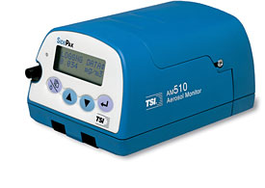
Air Quality Monitoring Field Protocol
Inlet
PAGE key
ENTER key

SidePak AM510 Personal Aerosol Monitor

PREPARATION

- Charge the battery pack
  - Plug the battery charger into the Power Port on the side of the SidePak (!!!Only use the supplied battery charger to prevent damage to the device!!!)
  - Plug the battery charger into a 3-prong AC outlet
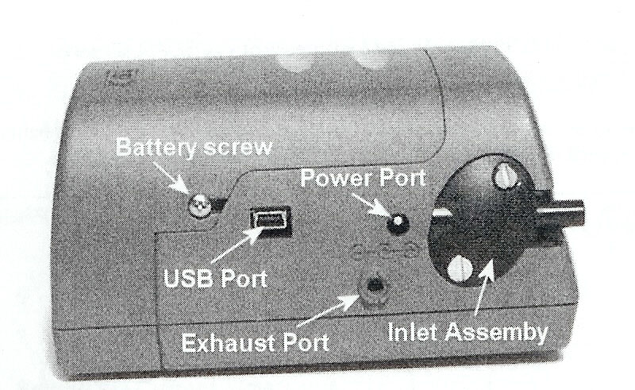
  - The display on the SidePak should intitially say “Detecting Battery Type” and then will say “Charging Battery”. The screen will indicate when charging is complete; charging may take up to 5.5 hours.
- Clean and grease the impactor
  - Remove the “Inlet Assembly” from the side of the SidePak by removing the 2 screws with the supplied flat head screwdriver
  - Make sure the outside of the inlet assembly is labeled “2.5μm”. This is the assembly that must be used to measure PM_{2.5.}
  - Remove the impactor insert from the inlet assembly by popping it out with the screwdriver
  - Wipe of the end of the impactor with a tissue or towel
  - Smear a very small amount of the supplied grease on the end of the impactor
  - Carefully slide the impactor back into the inlet assembly until it is fully seated
  - Reattach the inlet assembly to the SidePak with the two screws previously removed
- Zero calibrate the device
  - Press PAGE key to turn monitor on.
  - Wait about 1 minute for pump to start up and readings to stabilize. Display will read “SURVEY MODE”.
  - Press PAGE key then down arrow until “Zero Cal” is displayed. Press ENTER.
  - Attach Zero Filter and press ENTER again.
  - Wait until zero calibration is finished, this will take 60 seconds, then press PAGE key until back in survey mode.
  - With the Zero Filter still attached verify that the reading stays near 0.000 mg/m³ or below 0.003 mg/m³. If the reading is not near 0.00 mg/m³ then repeat the zero calibration until it is.
  - Remove Zero Filter.

OPERATION (SidePak)

- If not already on, press PAGE key to turn the SidePak on.
- Wait about 1 minute for pump to start up and readings to stabilize. Display will read “SURVEY MODE”.
- Press PAGE key.
- At “Data Log” press the ENTER key.
- Press down arrows until “Run Manual” is displayed. Press ENTER key. Screen should now display “Data Logging”. NOTE: If you are also using a Q-TRAK, this step should be done at the same time as Operation Step 5 for the Q-TRAK. This will ensure that both devices start logging at the same time.
- Lock the device: Press and hold the UP ARROW key and then press ENTER. This will lock the device and prevent accidentally pressing any of the buttons during logging.
- Record the time at which you started logging.
- Attach length of Tygon (clear plastic) tubing to the inlet. Place SidePak in bag with end of plastic tubing protruding from bag. Make sure the end of the plastic tubing is unobstructed. Also, make sure the small outlet hole on the left side of the SidePak is unobstructed.
- When air monitoring is complete, remove the SidePak from the bag.
- Unlock the device: The same as in Step 6, Press and hold the UP ARROW key and then press ENTER.
- Press the ENTER key 2 times to stop data logging.
- Press the PAGE repeatedly until the device returns to SURVEY MODE.
- To turn off the SidePak hold down the PAGE key for 3 seconds.
Inlet
PAGE key
ENTER key
DOWNLOADING DATA (SidePak)

- Turn on the PC and make sure that the TrakPro software verson 3.40 or later is installed.
- If not already on, press PAGE key to turn the SidePak on.
- Take the larger end of the USB cable and insert it into an available USB port on the PC.
- Take the small (miniUSB) end of the USB cable and insert it into the USB port on the side of the SidePak.
- Open the TrakPro software
- Make sure “SidePak Aerosol Monitor” is selected from the drop-down menu.
- Go to the “File” menu and select “Receive”. The PC will then communicate with the SidePak and display the logged data currently stored in the SidePak memory.
- Select the relevant logged data and click “Receive”. The PC will then download the selected logged data to the PC.
- The data can then be saved to the PC, transferred to another program such as Excel, or viewed graphically with TrakPro.
Inlet
PAGE key
ENTER key
Q-TRAK Plus
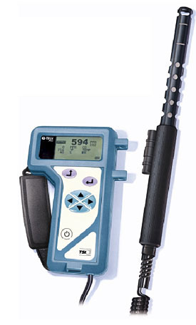
PREPARATION

- Insert 4 new AA batteries into the Q-TRAK

OPERATION

- Press POWER key and wait for device to start up
- Press ESCAPE key once to get to MAIN MENU
- Press down arrow to highlight LOG MODE 1; then press ENTER
- Check to make sure the LOG INTERVAL reads 01:00 or 1 minute and 0 seconds
- Press ENTER again to start logging. NOTE: This step should be done at the same time as Operation step 5 for the SidePak. This will ensure that both devices start logging at the same time.
- Lock the device: Use the tip of a pen to flip the toggle switch on the right side of the Q-TRAK down. This will lock the device and prevent accidentally pressing any of the buttons during logging.
- Record the time at which you started logging.
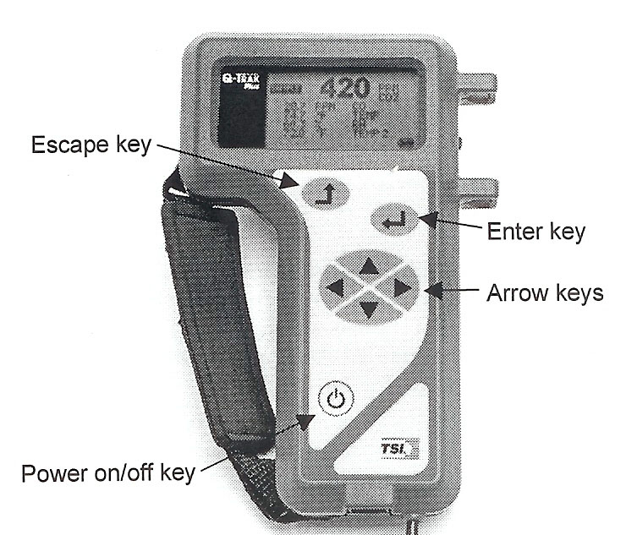
- Place the Q-TRAK in bag with the probe protruding from the bag
- When air monitoring is complete remove the Q-TRAK from the bag and use a pen to flip the toggle switch on the right side of the Q-TRAK up. This will unlock the Q-TRAK.
- Press ENTER to stop data logging.
- Press the POWER key to turn off the device.
DOWNLOADING DATA (Q-TRAK)

- Turn on the PC and make sure that the TrakPro software verson 3.40 or later is installed.
- If not already on, press POWER key to turn the Q-TRAK on.
- Take the larger end of the serial cable and insert it into an available serial port on the PC.
- Take the small end of the USB cable and insert it into the serial port on the bottom of the Q-TRAK.
- Open the TrakPro software
- Make sure “Q-Trak Plus” is selected from the drop-down menu.
- Go to the “Instrument Setup” menu and select “Communications…”.
- Click on “Find Port” and the computer will find and communicate with the Q-TRAK.
- If the PC successfully finds the Q-TRAK click on “OK” to close the “Communications” window.
- Go to the “File” menu and select “Receive”. The PC will then communicate with the Q-TRAK and display the logged data currently stored in the Q-TRAK memory.
- Select the relevant logged data and click “Receive”. The PC will then download the selected logged data to the PC.
- The data can then be saved to the PC, transferred to another program such as Excel, or viewed graphically with TrakPro.
MEASURING ROOM DIMENSIONS

Zircon DM S50 Sonic Measure

The sonic measure is a device that is used to measure distances quickly and easily. For this study the device will be used to measure the length, width and height of the room where air monitoring is done. This protocol refers specifically to the Zircon Sonic Measure but any similar sonic measuring device may be used. To use:

- The device should be turned on by pressing the “PWR” button.
- To measure a distance the device should be pointed at a 90-degree angle to the wall or ceiling in question.
- Then press the “READ” button.
- The device will take about a second to measure the distance from the back of the device to the object it was pointed at.
- The distance will be reported on the display in feet and inches.
- NOTE This device does not save the measurements you make. So, each measurement must be recorded by hand on a sheet of paper after it is made
- For example, in order to measure the length of a room you can stand somewhere in the middle of the room and measure the distance from you to the wall. Then, you can turn the device around (180-degrees) and measure the distance to the opposite wall. By adding these two measurements together you will have the length of the room (write it down!).
- Alternatively, you can stand up against a wall and measure the distance from that wall to the opposite wall to get the length/width of the room.
- NOTE This device can only measure up to 50 feet. So, by standing up against a wall you can only measure the distance to the opposite wall if it is less than 50 feet away. However, by standing in the middle of the room you can measure a distance of up to 100 feet; i.e. 50 feet each way.
- Things to watch for-
  - Sometimes it is difficult to get a clear line of sight to the wall you wish to measure the distance to. This is especially true in a crowded venue.
  - You may have to hold the device over your head or wait for space to clear to get a good measurement.
  - It is always best to estimate the distance you are measuring and compare it to what the sonic measure says. Sometimes you may think the device is measuring the distance to the wall but instead it actually measured the distance to the pole or person between you and the wall. Ask yourself, “Does this measurement make sense?”.
- If it is impossible to obtain an accurate measurement due to the size of the venue, obstructions, or the number of people you can estimate the distances by pacing or walking the distance. One large stride for an average size person equals approximately 3 feet. So if you take 25 large paces to get a across a room, the distance is 75 feet. Ideally, this method can be used to check the measurements you get with the sonic measure. However, only rely exclusively on pacing as a last resort. If measurements have to be estimated make sure to note which measurements are estimates.
- Odd shaped rooms: It is sometimes difficult to measure the size of a room if it is not rectangular or square shaped. The easiest thing to do is to measure the room in parts. For example, in an L-shaped room you could just treat this as 2 rectangular rooms and measure them separately. In cases like this it is best to draw a little diagram of the shape of the room and label the length of each wall on your diagram after you measure it.

. National Toxicology Program. 9th Report on Carcinogens 2000. Research Triangle Park, NC: U.S. Department of Health and Human Services, National Institute of Environmental Health Sciences; 2000.
. CDC. Annual smoking-attributable mortality, years of potential life lost, and economic costs – United States, 1995-1999; MMWR 2002;51(14):300-320.
. US Department of Health and Human Services. Second national report on human exposure to environmental chemicals. Atlanta, GA: US Department of Health and Human Services, Centers for Disease Control and Prevention, National Center for Environmental Health, 2003.
. U.S. Department of Health and Human Services. Reducing tobacco use: a report of the Surgeon General. Washington, D.C.: US Government Printing Office, 2000.
. Hopkins DP, Briss PA, Ricard CJ, Husten CG, Carande-Kulis VG, Fielding JE, et al. Reviews of evidence regarding interventions to reduce tobacco use and exposure to environmental tobacco smoke. Am J Prev Med 2001;20(2 Suppl):16-66.

